due date

10/29/2019



CSCE 608 Project I

Jennifer yu

UIN: 623000406

# CSCE 608 - Project I

## project description

What inspired me to create this database is t

The project aims to provide students future reference about a specific course’s GPA distribute, or a specific instructor’s tendency to give high or low grades. It gathered historical grades information from year 2015-now at Indiana University Bloomington.

Users are able to modify the data such as register as an user, insert, select, and delete, modify a single or multiple rows. Users can look into summary about a course’s history grade distribution taught by a specific instructor; they can also narrow it down to a specific semester. Or in general it pop out a summary to compare between any two courses.

## Entity-relationship diagram

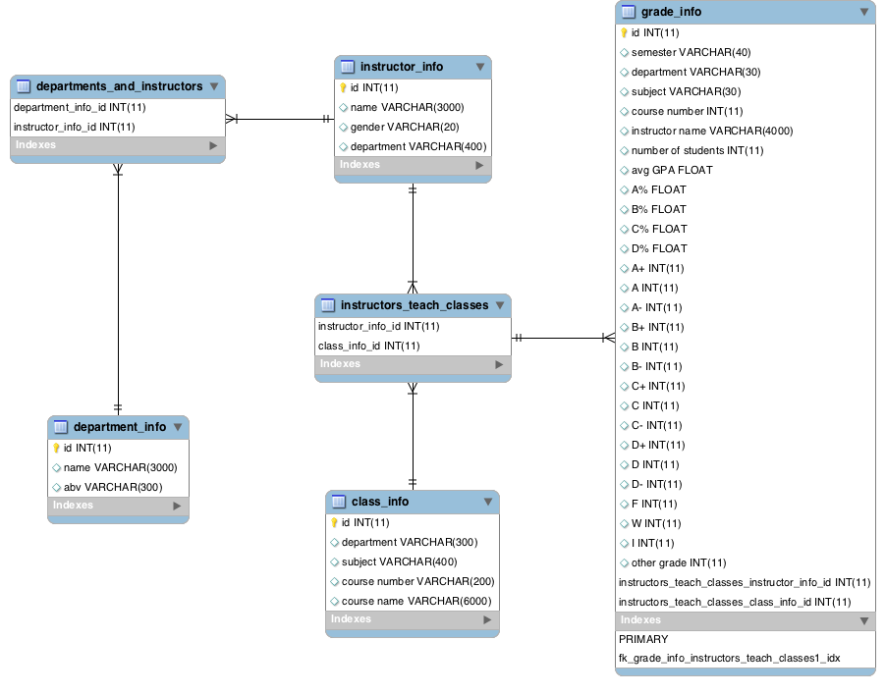

## table normalization

Th

## data collection

There are four tables with varies number of tuples:

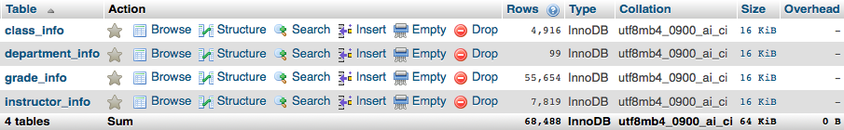

The class_info table contains information such as department name, subject name, course number and course name, a specific class may be tought by several instructors. The same course may repletely appear in different years (spring, 2015 & spring 2016, etc.);

The department_info table holds information which just has two columns, the department name and its abbreviation;

The instructor_info table has information of the lector’s name, gender, department, noticed that an instructor may belongs to multiple departments;

The grade_info contains most columns and most tuples (more than 50k). It contains every single course’s information especially grades distribution (Average, A%, B%, etc.) for all semesters from year 2015-2019.

The data sources are:

1. <http://gradedistribution.registrar.indiana.edu>
2. <http://enrollmentbulletin.indiana.edu/pages/deptabbr.php?t=spring>

## User interface

## discussion

## project source code